|  |  |  |  |  |  |
| --- | --- | --- | --- | --- | --- |
| Date | 8-Sep-22 | | | Tester Name | Mohammad Yusuf |
| Environment | Penfax - Test | | | Login used |  |
| Operating System | Select OS | Version: | Update: | | |
| Software Used | Select Software | Version: | Update: | | |
| Select Software | Version: | Update: | | |
| Release version |  | | | | |
| Title | M17 Contributions & DCT | | | | |
| Test Type | Regression | | | | |
| Test Scenario | M17.24 View Tutorials | | | | |
|  |  | | | | |
| Expected Results | ‘MEPP Employer Guide’ should redirect a user to administration guide.  ‘How to use PLANet’ link should redirect a user to Tutorial page. | | | | |
| Pass/Fail | Fail | | | JIRA# | N/A |

Describe your steps with screenshots:

1. Log into MEPP DCT and click on Tutorials.

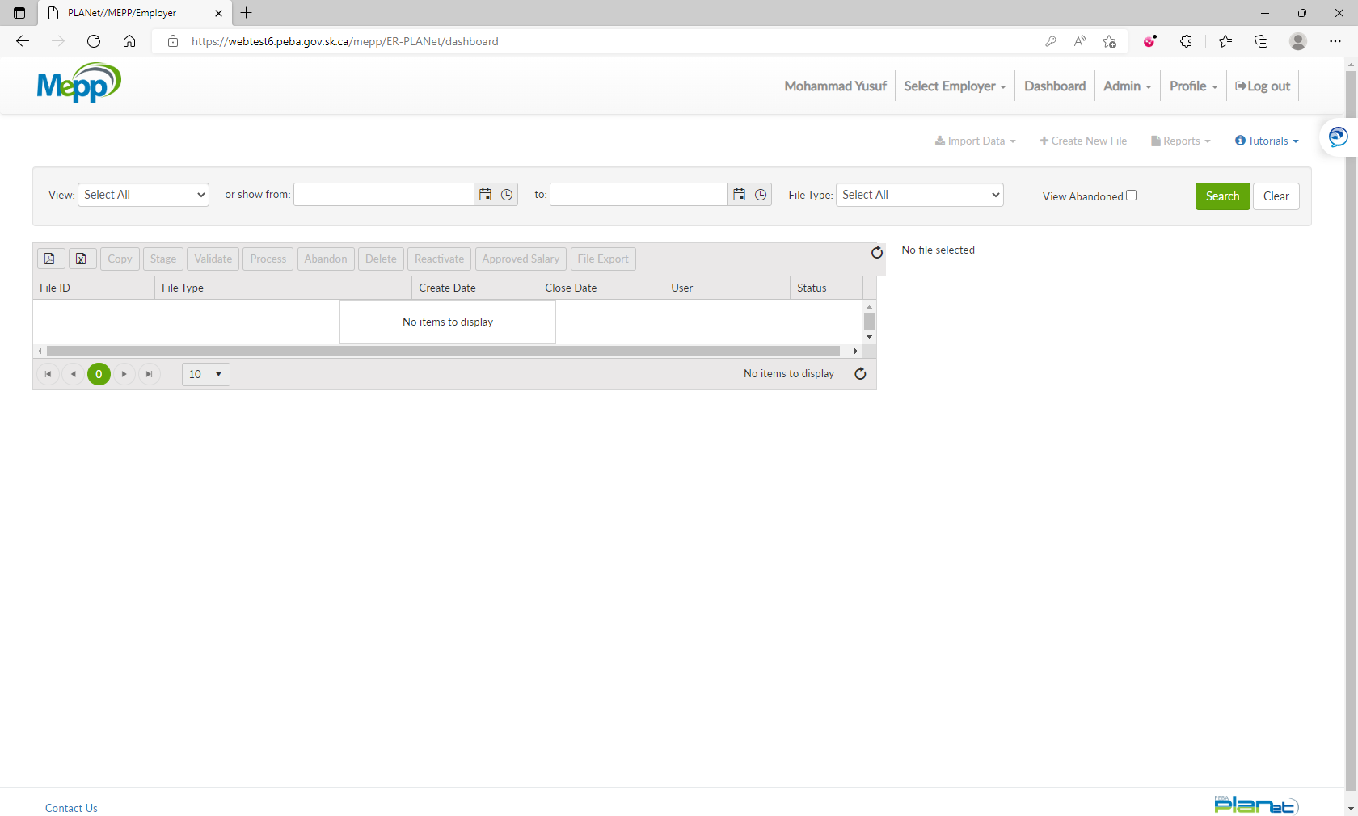

1. Select MEPP Employer Guide from the drop down.

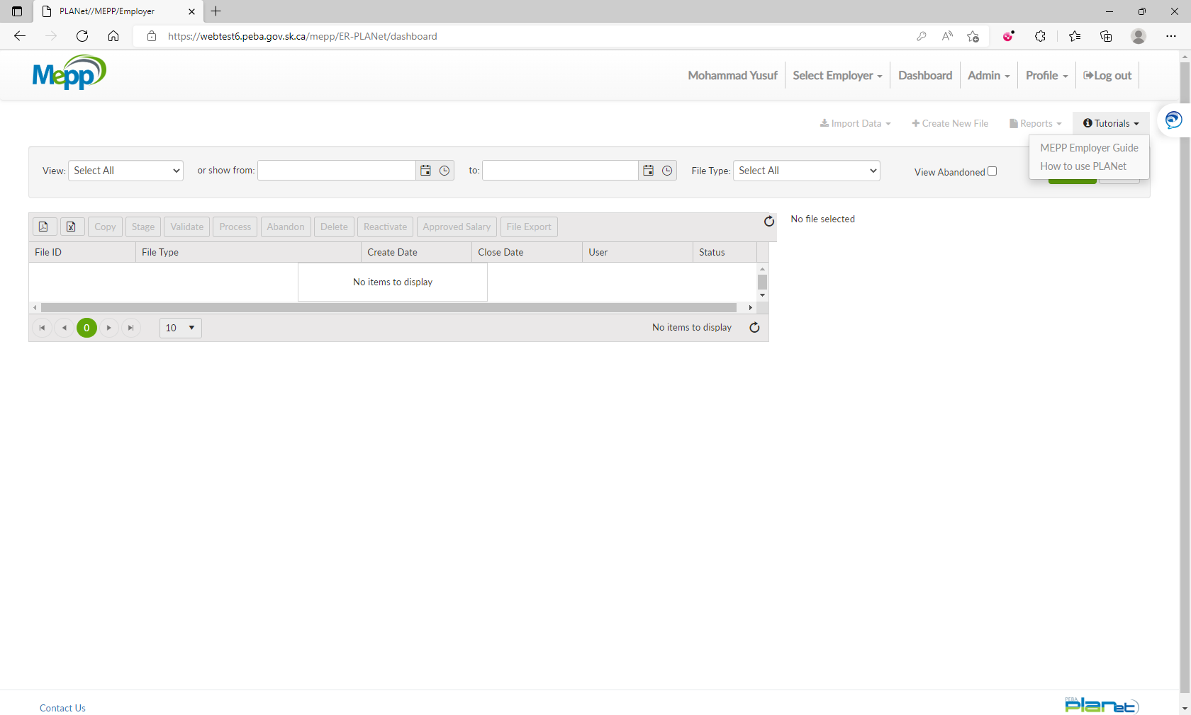

1. It will redirect to the administration guide.

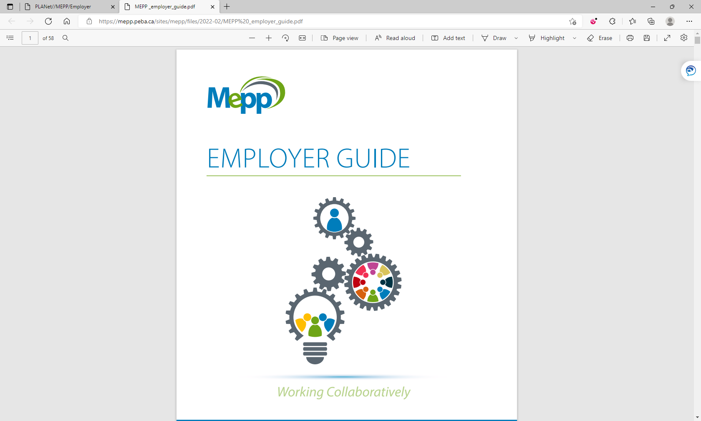

1. Select How to use PLANet from the drop down.

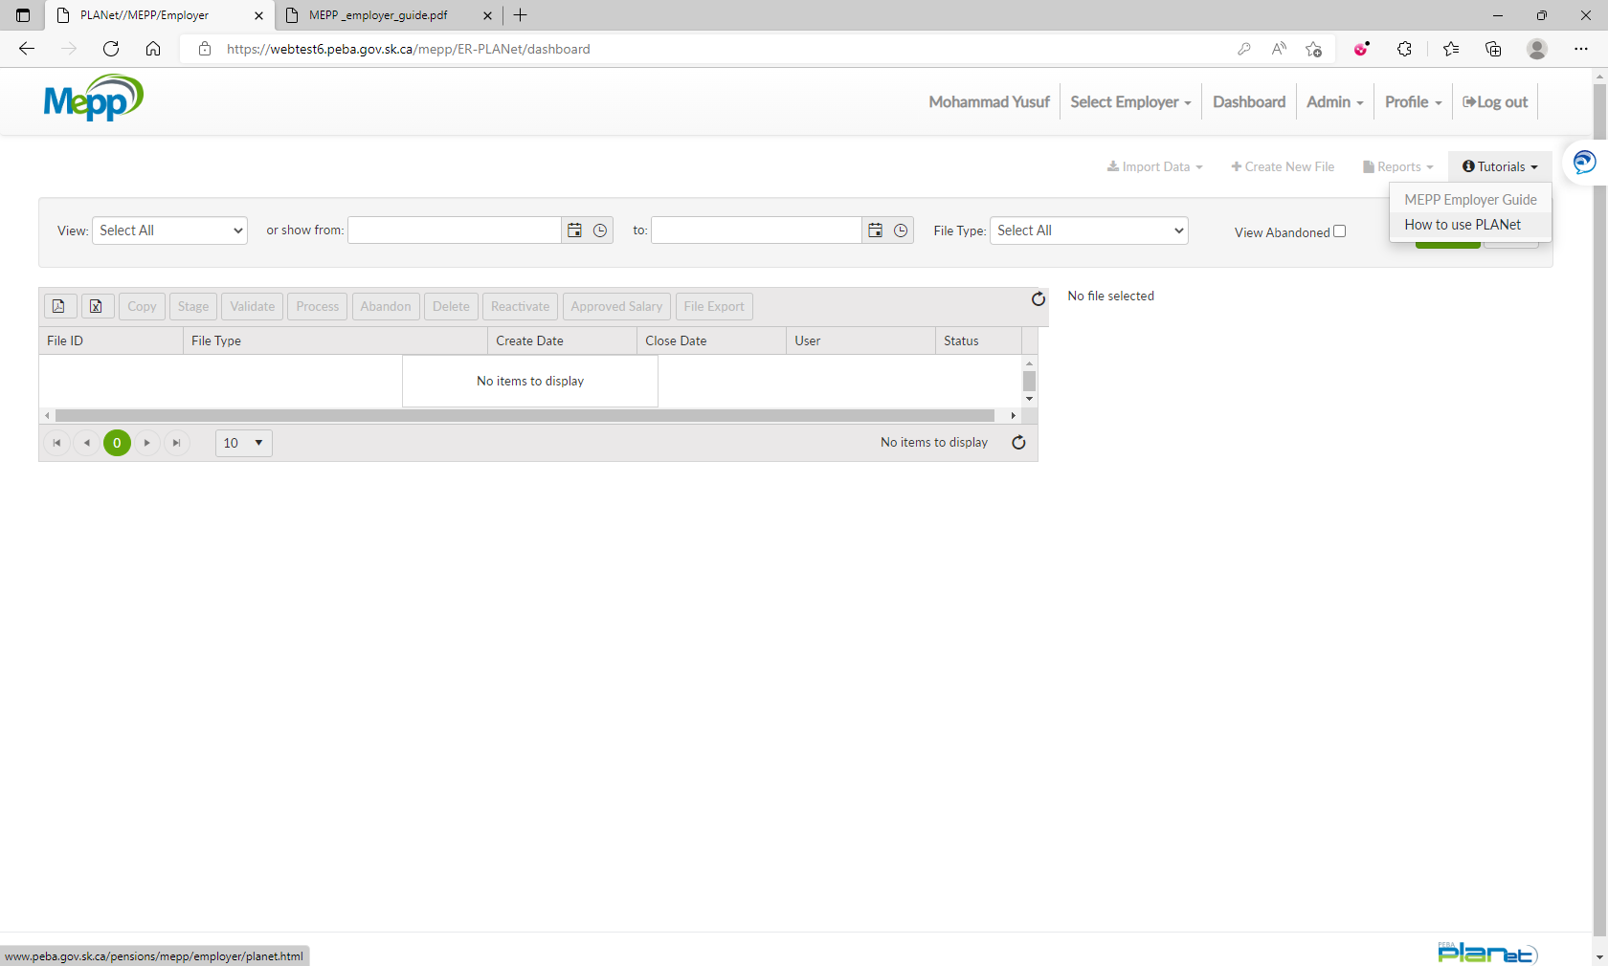

1. It will redirect to the Tutorials page.

